INSTRUCTION MANUAL FOR HANDLING GAS CYLINDER
SAFETY

WARNING
A gas cylinder has flammable gas that must be handled well and any leakage must be handled well by an expert to avoid the damage that could occur.
SAFE OPERATING PROCEDURE: XGK Gas Cylinders
INTRODUCTION
These instructions needs to adhere so as to avoid potential hazards such as fire due to explosions. This manual includes graphics that are aimed at indicating the level of danger that is associated with poor handling and usage. Our organization is always ready to offer assistance whenever contacted. The gas needs to be handled by people with relevant knowledge and to avoid mistakes that could result to accidents.
Safety tips
- Do not allow any kind of leakage on the gas
- Do not store it with corrosive liquids
- Store it in the right temperatures to avoid any explosion or damage
- Do not damage the gas nob to prevent leakage
- If you don’t have sufficient knowledge about the hazards and risks associated with the gas then you can contact your supplier
INDOOR HANDLING THE GAS
When handling the gas, it should be handled by a person who have knowledge and understanding of the hazards (Paliwal, Agrawal, Srivastava, and Sharma, 2014). The person must therefore be familiar with the proper handling techniques. The cylinder is heavy and therefore it may cause explosions, falls and even broken bones.
- Never drag the cylinder on the floor when moving it
- Obtain proper handling training or information relevant
- Secure the cylinder caps and valves when not in use to avoid leakage
- Do not move the cylinder while the cap is attached

Figure 1: Recommendation of how to handle your gas
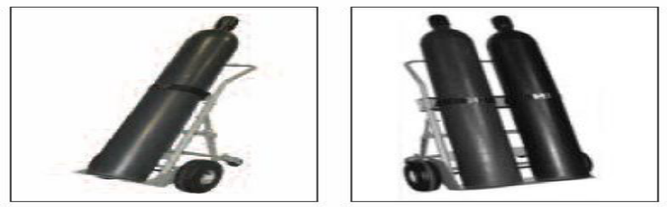
(Reference: Matheson - Safe Handling of Compressed Gases in the Laboratory and Plant 2011)
Figure 2: Example of poor storage of the gas with an arc of corrosion
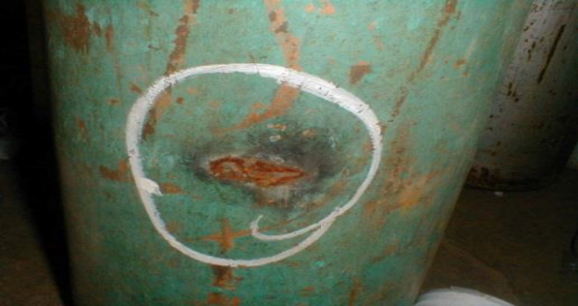
(Reference: www.engineeredinspection.com;www.nautinst.org)
PROPER CYLINDER STORAGE
The room that the gas is stored and used should be well-ventilated. Sources of ignition, and heat should be kept far from the cylinder in order to avoid fire. Areas that are near boilers, steam and any source of heat must be avoided with all costs. Moreover, the cylinder should be protected against unauthorized personnel.
THE CYLINDER USE
The home cylinder use need to be connected by a qualified person. This is a precaution that shall ensure that there is limited hazard exposures such as explosions. The following steps are taken when connecting it to your cooking cooker.
- Connect the valve through the valve or regulator to deliver the gas to the gas cooker
- Tighten it well to avoid any gas leakage in the process of cooking gas
- Turn on the valve slowly to allow the gas flow through the horse pipe connected

Steps to connect your gas
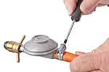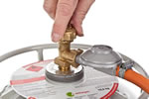
Fig 3. Smart gas cylinder using embedded system (Priya, Surekha, Preethi, Devika, and Dhivya, 2014)
MAINTENANCE OF THE CYLINDER
Always keep the cylinder clean and avoid any possible contamination or moisture exposure on the gas. This will ensure that the gas is not exposed to more risks. For example, the cylinder should not be exposed to temperatures that are above (52°C). Therefore, there is need to ensure that the gas is stored in the right space and approach.

References
Paliwal, G., Agrawal, K., Srivastava, R. K., & Sharma, S. (2014). Domestic liquefied petroleum gas: Are we using a kitchen bomb?. Burns, 40(6), 1219-1224.
Priya, K. P., Surekha, M., Preethi, R., Devika, T., & Dhivya, N. (2014). Smart gas cylinder using embedded system. International Journal of Innovative Research in Electrical, Electronics, Instrumentation and Control Engineering (IJIREEICE) Vol, 2, 958-962..

